1 | Explain Network Virtualization
Soln:-
Network virtualization: Creating virtual networks within a physical network to manage and use resources more efficiently.

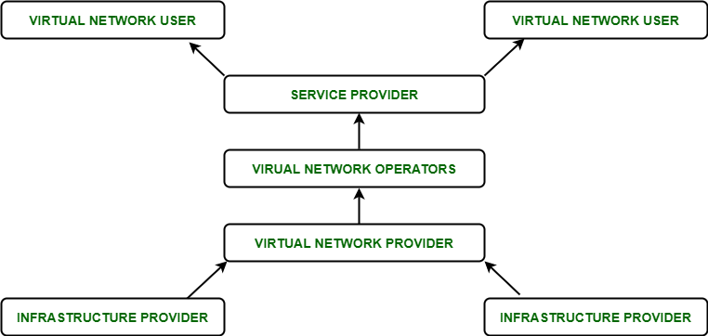

Architecture:
Physical switch OS: Software that enables network virtualization functionalities.
Hypervisor: Software that creates virtual switches and networks.

Functions:
Grouping: Organizing nodes into virtual networks.
Sharing: Allowing virtual networks to share resources.
Direct communication: Nodes within a virtual network can talk without extra routing.
Management traffic control: Limiting management traffic.
Enforced routing: Making sure communication between virtual networks follows specific routes.

Advantages:
Easy management: Makes organizing nodes simpler.
Cost reduction: Saves money by needing fewer physical networks.
Better use of resources: Multiple virtual networks can share the same physical network.
Improved performance: Limits network congestion, making things faster.
Enhanced security: Keeps sensitive data isolated and access controlled.

Disadvantages:
More abstract management: Management might become less straightforward.
Integration challenges: Might be tricky to work with physical devices alongside virtual networks.
Increased complexity: Adds more layers of complexity to the network.
Upfront cost: Might require initial investment.
Learning curve: Might take time to get used to it.

Examples:
Virtual LAN (VLAN): Creates separate networks for better performance and management.
Network overlays: Protocols like VXLAN overlay virtual networks on top of physical ones.
Network Virtualization Platform: Solutions like VMware NSX manage network components in software.

Applications:
Testing: Helps simulate real-world conditions for testing applications.
Integration: Makes it easier to combine or split up physical networks.
Performance engineering: Simulates different connections to test software performance.
Faster deployment: Speeds up getting applications up and running.
Testing optimization: Helps find and fix network issues during software testing.

2 | Explain how Storage As A Service is different from Software As A Service.
Soln:-

Aspect | Storage as a Service (STaaS) | Software as a Service (SaaS)
Definition | Provides remote storage resources over a network on subscription. | Delivers software applications over the internet on subscription.
Functionality | Offers storage space, data backup, retrieval, and management services. | Provides access to hosted software applications with full functionalities.
Example | Dropbox, Google Drive, Amazon S3 | Google Workspace (formerly G Suite), Microsoft Office 365
Usage | Storing and managing data remotely, data backup and recovery. | Accessing and using software applications via the internet, collaborative work, project management.
Focus | Storage infrastructure, data management, and backup. | Delivering a range of software applications for various business needs.
Access | Accessible via web interfaces, APIs, and client applications. | Accessed through web browsers, dedicated apps, or APIs.
Scalability | Scalable storage capacity based on subscription plans. | Scalable based on the number of users or features required.

3 | What is the walrus storage controller? Explain the working of this particular module in detail.

Soln:
The Walrus Storage Controller is a component of the Eucalyptus cloud computing platform, designed to provide object storage services similar to Amazon Simple Storage Service (S3). It serves as the storage backend for storing virtual machine images, snapshots, and other data within the Eucalyptus cloud infrastructure.
Working of the Walrus Storage Controller:
Storage Backend:
- Efficiently stores data objects in a flat namespace structure.
- Optimizes storage utilization through effective data organization.
- Supports various data types, including virtual machine images and user files.
Object Storage:
- Facilitates seamless upload and download of objects for users.
- Enables versioning and metadata management for stored objects.
- Provides reliable storage with built-in error detection and correction mechanisms.
RESTful API:
- Simplifies integration with client applications through standardized HTTP requests.
- Allows developers to automate storage operations programmatically.
- Enhances interoperability by supporting multiple programming languages and platforms.
Authentication and Authorization:
- Ensures secure access to stored data with robust authentication mechanisms.
- Enables granular control over user permissions and access policies.
- Facilitates integration with existing identity management systems for streamlined user authentication.

Buckets and Objects:
- Enables efficient data organization and management through bucket creation.
- Supports object tagging for categorization and easy retrieval.
- Facilitates lifecycle management for automatic object expiration and archiving.
Data Replication and Durability:
- Ensures data integrity and availability through redundant storage mechanisms.
- Automatically replicates data across multiple nodes or regions for fault tolerance.
- Provides data durability guarantees with regular integrity checks and data scrubbing.

4 | List and explain the different services of CSB (Cloud Services Brokerage)
Soln:-

Cloud Services Brokerage (CSB) encompasses various services aimed at facilitating the consumption, integration, and management of cloud services. Here are the different services typically offered by CSB along with explanations:
Aggregation:
- Consolidates diverse cloud services into a unified catalog.
- Simplifies access for clients by offering a single point of entry.
Intermediation:
- Customizes and enhances cloud services to meet specific client requirements.
- Adds value by providing specialized services like data encryption or compliance management.
Arbitrage:
- Analyzes various cloud service offerings to recommend the most cost-effective options.
- Helps clients make informed decisions by comparing features and pricing across providers.
Integration:
- Facilitates seamless integration of cloud services with existing IT systems and applications.
- Ensures interoperability between cloud services and on-premises infrastructure.

Governance:
- Establishes policies and frameworks to ensure compliance with regulatory requirements and security standards.
- Mitigates risks associated with data privacy and security breaches through enforcement of best practices.

LAST THREE REMAINING 🙂

5. Explain the functioning of Cloud Storage Gateways with the help of a diagram.
Cloud Storage is a mode of computer data storage in which digital data is stored on servers in off-site locations. The servers are maintained by a third-party provider who is responsible for hosting, managing, and securing data stored on its infrastructure. The provider ensures that data on its servers is always accessible via public or private internet connections.
Cloud Storage enables organizations to store, access, and maintain data so that they do not need to own and operate their own data centers, moving expenses from a capital expenditure model to operational. Cloud Storage is scalable, allowing organizations to expand or reduce their data footprint depending on need.

How does Cloud Storage work?
Cloud Storage uses remote servers to save data, such as files, business data, videos, or images. Users upload data to servers via an internet connection, where it is saved on a virtual machine on a physical server. To maintain availability and provide redundancy, cloud providers will often spread data to multiple virtual machines in data centers located across the world. If storage needs increase, the cloud provider will spin up more virtual machines to handle the load.
Functioning:
- Data Ingestion: The Cloud Storage Gateway captures data from the on-premises storage system, typically through network connections or APIs.
- Data Processing and Optimization: The gateway may perform tasks such as data deduplication, compression, encryption, and format conversion to optimize data before transferring it to the cloud. These processes help reduce bandwidth usage and storage costs.
- Data Transfer: Optimized data is then transferred securely over the internet to the cloud storage service.
- Data Retrieval: When needed, the gateway retrieves data from the cloud storage service and delivers it to the on-premises storage system.
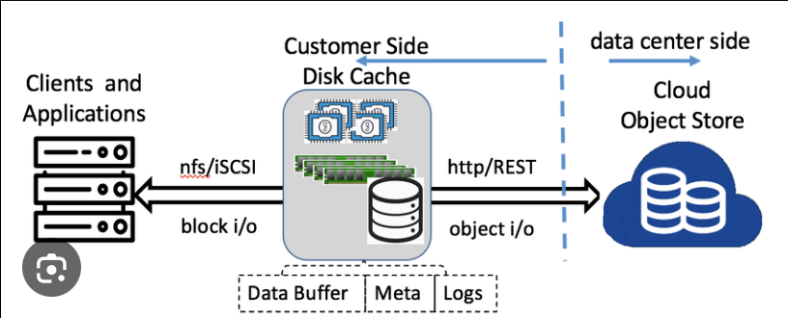

6. Describe in detail the working of the AAA model in cloud computing.
A standard-based framework called AAA is used to manage who is allowed to access network resources, what they are allowed to do, and record the actions taken while doing so (via authentication and Authorization). Or we can say, the AAA is a structural framework used to access computer resources, enforce policies, conduct audits, provide vital data for service billing, and perform other network administration and security tasks. The primary purpose of this operation is to grant specific, Authorized user's access to network and software application resources. A technique for monitoring and controlling user access to network resources on an IP-based network is authentication, Authorization, and accounting (AAA).
Authentication -
It is a method of determining if a user who wants to access network resources is legitimate or not, and it is done by requesting certain credentials, such as a username and password. Authentication can be enabled on console ports, AUX ports, or vty lines, among other places.
If someone wants to enter the network, we, as network administrators, can manage how a user is authenticated. These techniques include utilising the router's internal database or submitting authentication requests to a remote server, such as the ACS server.
Authorization -
After the user has obtained access to the network resources through authentication, it offers the ability to enforce policies on those resources. When authentication is successful, Authorization can be used to identify which resources and processes the user is permitted to access.
For instance, if a junior network engineer wants access to the device but shouldn't have access to all the resources, then the administrator can construct a view that would only allow him to perform certain commands.
Accounting -
It offers tracking and recording of user actions as they use network resources. Even the length of the user's network access is tracked. The administrator can construct an accounting method list to designate what should be accounted for and who should receive the accounting records.

7. Explain the structure of Google App Engine’s Data Store and its underlying technologies
A scalable runtime environment, Google App Engine is mostly used to run Web applications. These dynamic scales as demand change over time because of Google’s vast computing infrastructure. Because it offers a secure execution environment in addition to a number of services, App Engine makes it easier to develop scalable and high-performance Web apps. Google’s applications will scale up and down in response to shifting demand. Croon tasks, communications, scalable data stores, work queues, and in-memory caching are some of these services.
The App Engine SDK facilitates the testing and professionalization of applications by emulating the production runtime environment and allowing developers to design and test applications on their own PCs. When an application is finished being produced, developers can quickly migrate it to App Engine, put in place quotas to control the cost that is generated, and make the programmer available to everyone. Python, Java, and Go are among the languages that are currently supported.
The development and hosting platform Google App Engine, which powers anything from web programming for huge enterprises to mobile apps, uses the same infrastructure as Google’s large-scale internet services. It is a fully managed PaaS (platform as a service) cloud computing platform that uses in-built services to run your apps.

